Lab Exercise 21- Building a Docker Image for

an HTML App Using Nginx

Setup

You will need:
  - Docker installed on your machine.
  - A simple HTML file for the app.

Step 1: Create the HTML File
Create a directory for your HTML app and place an index.html file in it.

mkdir nginx-html-app

cd nginx-html-app

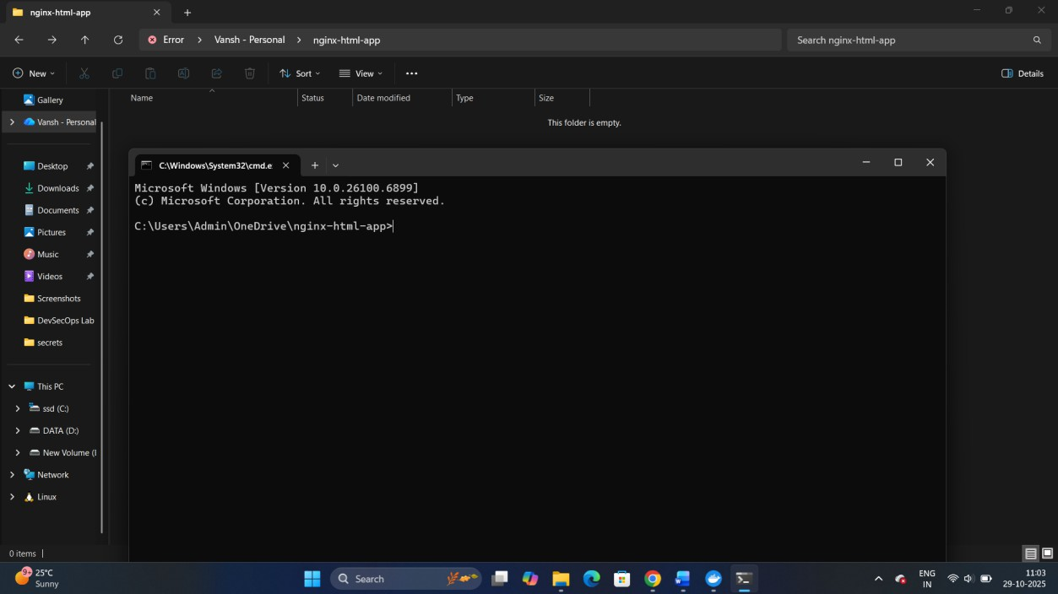
Inside the nginx-html-app directory, create the HTML file.

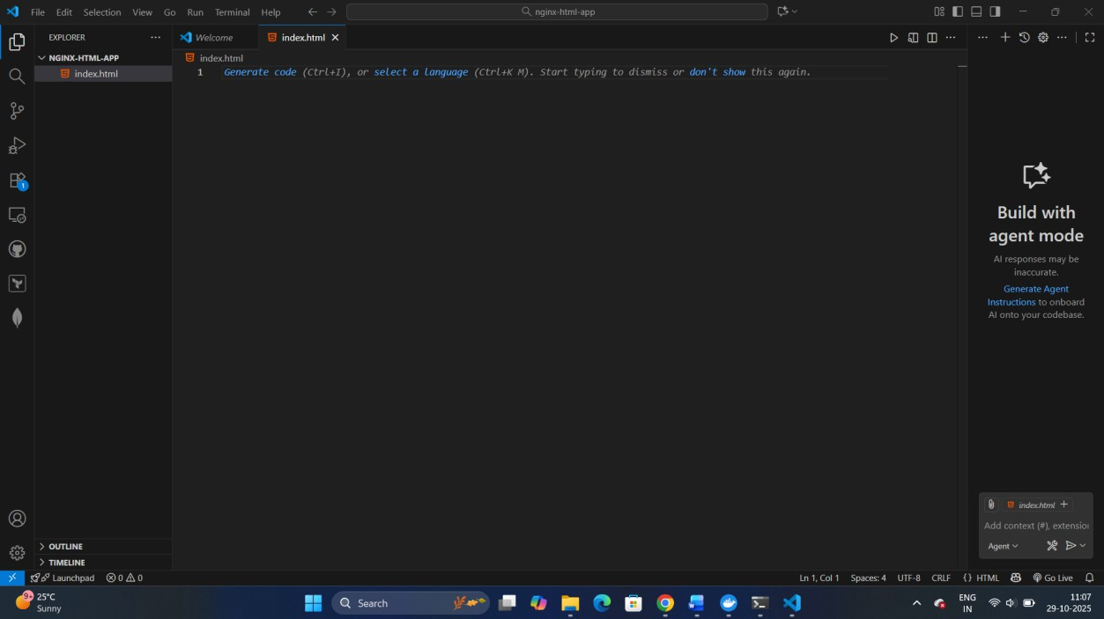
touch index.html

Edit the index.html file with the following content (or any custom HTML content you want):

<!DOCTYPE html>
<html>
<head>
<title>Welcome to My Nginx HTML App</title>

</head>

<body>
<h1>Hello, Nginx Docker!</h1>
<p>This is a simple HTML app served by Nginx in a Docker container.</p>

</body>

</html>

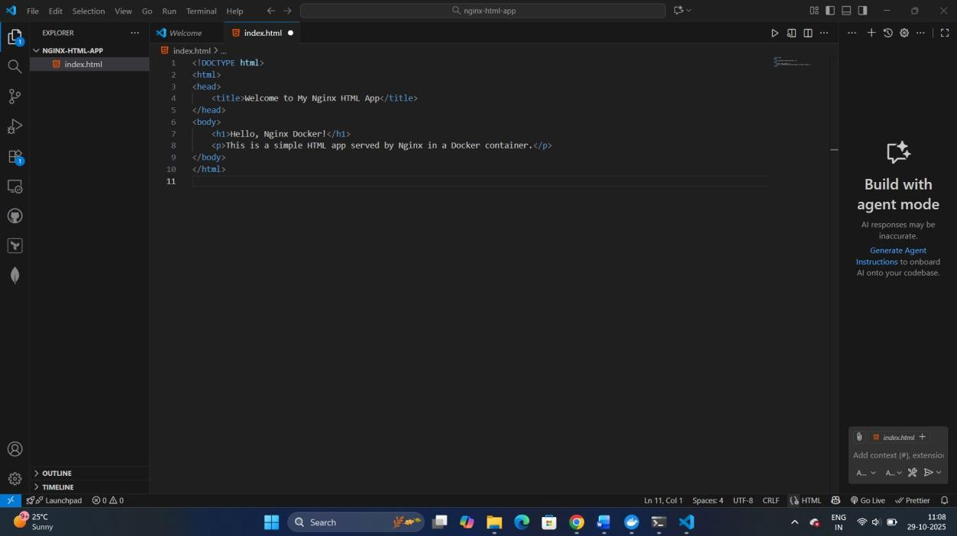
Step 2: Create a Dockerfile
In the same directory, create a Dockerfile. This file will define how to build the Docker image using Nginx as the base image.
touch Dockerfile

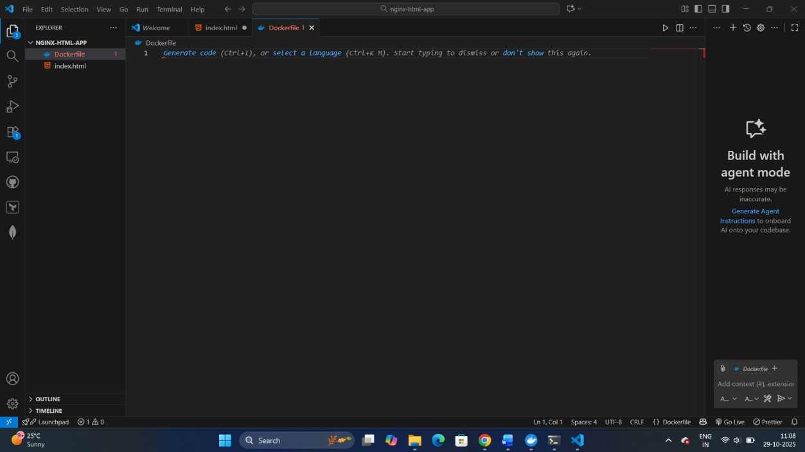

Edit the Dockerfile and add the following content:
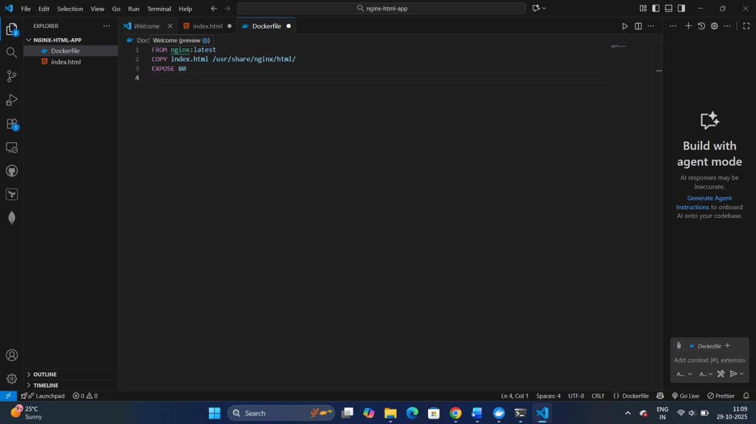
FROM nginx:latest
COPY index.html /usr/share/nginx/html/ EXPOSE 80

Step 3: Build the Docker Image

Now that you have the Dockerfile and index.html, it’s time to build the Docker image.
Run the following command to build the image, giving it a tag (e.g., nginx-html-app):

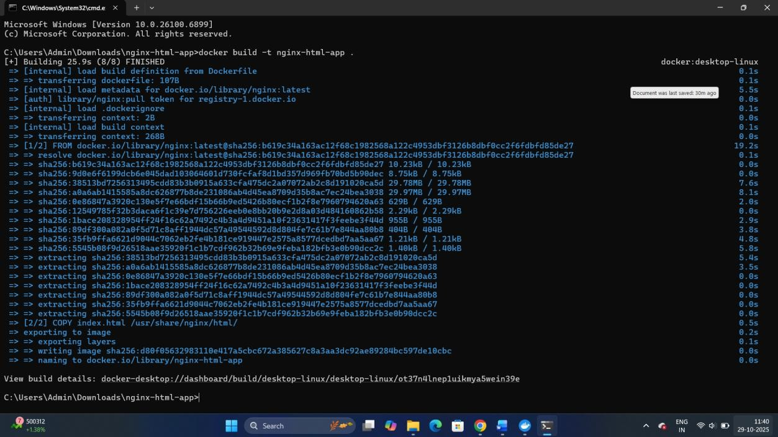
docker build -t nginx-html-app .

Docker will use the Nginx base image, copy your index.html into the appropriate directory, and build the image.

Step 4: Run the Docker Container

After building the image, you can run the container with the following command:
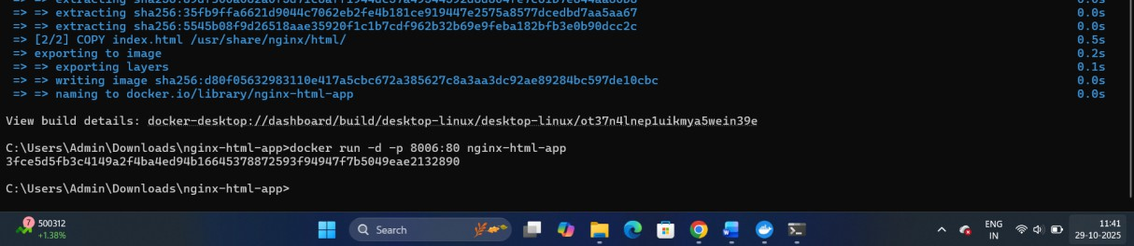
docker run -d -p 8006:80 nginx-html-app

This command runs the container in detached mode (-d) and maps port 8006 on your host machine to port 80 inside the container, where Nginx is serving your HTML app.

Step 5: Verify
Open a browser and go to http://localhost:8006. You should see your HTML page with
the message “Hello, Nginx Docker!”.
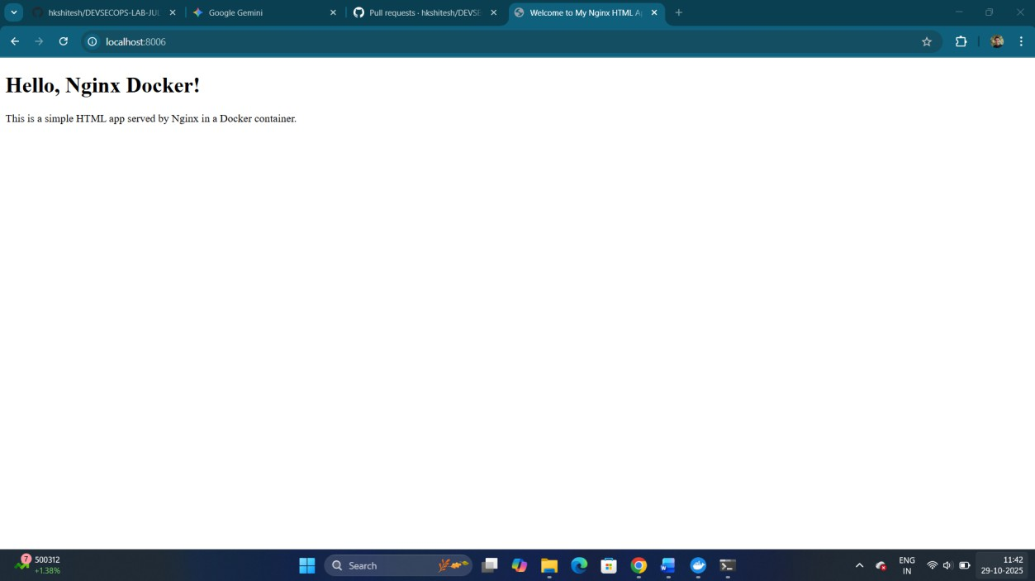

Step 6: Stop and Remove the Container
Once you're done, you can stop and remove the container:

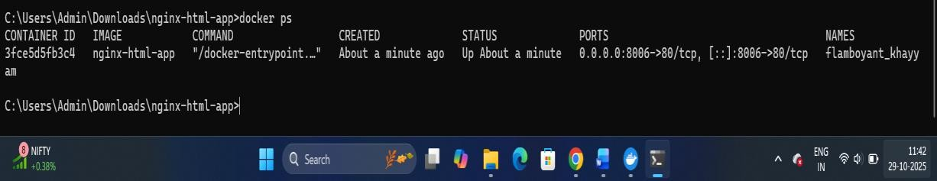
docker ps # to see running containers

docker stop <container-id>

docker rm <container-id>

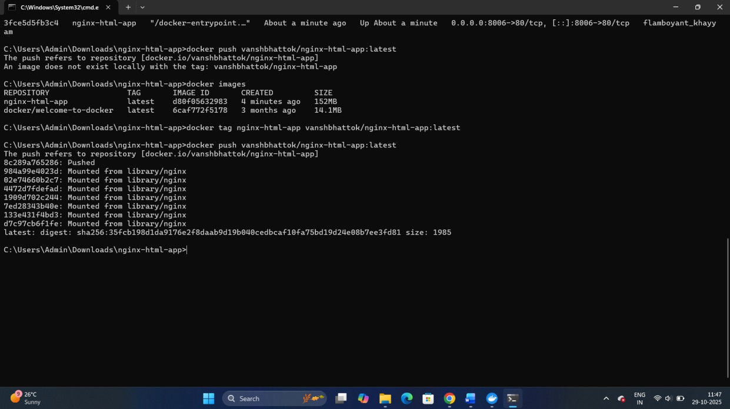
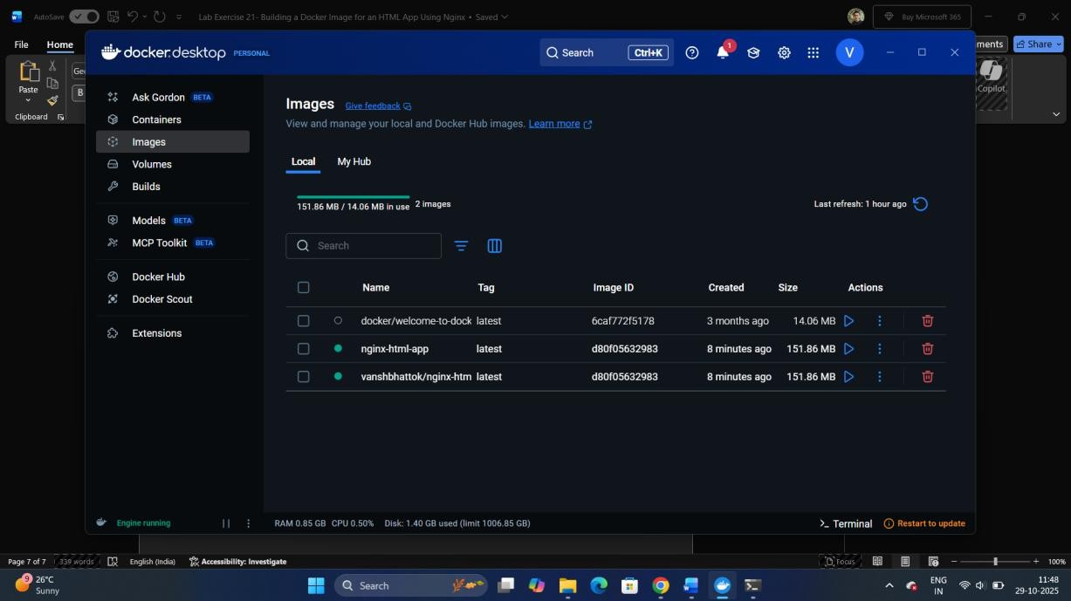
Step 7: Tag the local image and push it to DocHub (Done by Self)

Thank You!

